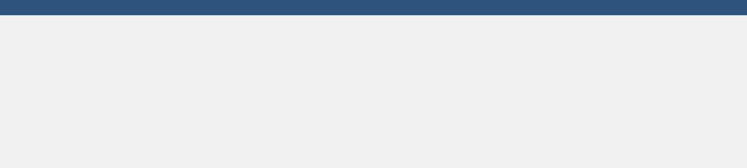



Critical Thinking

Writing & Research

Leadership

Handling Pressure

Time Management

Strong Work Ethic

Collaboration.

Problem Solving

I am looking for an opportunity in a reputed organization which will help me deliver my best and upgrade my skills in engineering and meet the demands of the organization.

**EXPERIENCE**

**SKILLS**

**R E S U M E O B J E CT I V E**



C:\Users\abdou\Desktop\Resumes for Customer\Customer Project\Resume 5\phone.pngC:\Users\abdou\Desktop\Resumes for Customer\Customer Project\Resume 5\location.pngC:\Users\abdou\Desktop\Resumes for Customer\Customer Project\Resume 5\mail.png

Adaptability.

**Mechanical Engineer (Production)** | Al Nubala’ Water Factory

*Abu Alanda- Jordan / June 2018 – May 2019* (Full Time)

My daily duties included conducting necessary water tests to ensure they met the required specifications, following-up hourly on water and bottles, ensure the shape of the final bottle is up to standards with no defects, ensure compliance with safety and hygiene procedures, and write a daily production report. Additionally, I communicated with line supervisors to solve problems and ensure the continuation of the production line work and coordinated with warehouses to follow up on the production process.

I learned how to use blowing machines (SMF), label machine, and shrink machine.

**International Students Administrator** | Kesan Educational Consulting

*Virginia- USA / May 2017- May 2018* (Part Time)

My daily duties included preparing documents for all intensive English course programs and ensure compliance with all federal policies and regulations and preparing and maintaining necessary distribution documentations for management. Additionally, I worked with delivery companies’ teams to coordinate delivery activities for our online bookstore, student’s documents, and company purchases. Also, I monitored shipping status regularly using Kesan software application, addressed students' and companies’ inquiries regarding applications, filling forms, universities and embassies requirements’ preparations, coordinated with faculty and staff members across departments, performed all duties as required, and provided administrative support to all international students’ admissions.





**Distribution Coordinator** | Aramex

*Khalda - Jordan / February 2014- March 2017* (Part Time)

My daily duties included coordination, planning, and execution of newspaper printing and marketing material. I conducted distribution operations as per company procedures, monitored distribution status regularly by contacting the team during distribution periods. Additionally, I received, handled, and stored newspapers and marketing materiel in warehouse effectively, prepared and maintained necessary distribution documentations for management, worked with materials department to arrange for supplies for distribution, and reviewed and recommended improvements for existing distribution instructions.

**Certified leader** | Bin Ouf Scout Group

*N. Marka - Jordan / June 2014- September 2017 (*Volunteer)

My daily duties included ensuring that the scout group thrives and has the best systems in place to support adult volunteers and develop the group including the group executive committee and section leadership teams. Additionally, I provided line management and support to the Leaders in the scout group including setting objectives for their work, holding regular reviews, and one-to-one meetings. I ensured that the scout group has an adequate team of support and appropriate adults working effectively together and with others to meet the scout needs of the area. I ensured that the programs we offer are challenging, exciting, and balanced.



Jordanian Engineers Association

Jordanian Scouts and Guides Association

AIESEC- Leaders of the World

**AFFILIATIONS**

* 5S
* Six Sigma
* Business ethics and management
* Meetings Management
* Inventory Management
* Financial Statements and evaluation of projects
* Writing reports and research
* Toyota production system (lean manufacturing)
* Microsoft office proficiency (Microsoft Power point, Microsoft Excel, and Microsoft Word). AutoCAD.

**COURSES**

BSc. Mechanical Engineering | Al-Balqa Applied University- 2018

**EDUCATION**